***BINARY CLASSIFICATION***

**Preview of Classification:**

In machine learning and statistics, grouping is a directed gaining technique wherein a PC programming gains from information and mentions new observable facts or characterization. Classification is the most common way of partitioning a bunch of information into particular classes. It very well might be applied to both coordinated and unstructured information. Foreseeing the class of information focuses is the most vital phase in the method. Target, mark, and classifications are normal terms for the classes.

Approximating the planning capability from discrete information factors to discrete result factors is the issue of grouping prescient displaying. The essential goal is to sort out which classification or class the new information has a place in.

In this blog we’ll discuss **binary classification** which is the most easiest and basic type of classification in ML.

**WHAT IS BINARY CLASSIFICATION?**

The objective of binary classification is to classify important pieces of information into one of two pails: 0 or 1, valid or bogus, true or false, blue or no blue eyes, and so on. We will go through two model situations of binary classification.

1. **Surviving the Titanic**: If you were a passenger: either you have survived or not survived the sinking of the Titanic (assuming you were on the Titanic).
2. **Weather Prediction**: You intended to go external out traveling with your companions now you need to know the expectation for later whether it is cold or stormy so these kinds of issues are tackled by binary classification.

**ACCURACY:**

AI model precision is one of the various measures used to evaluate a grouping issue's advancement. The quantity of right conjectures partitioned by the complete number of figures is precision: accuracy = correct number/total. An exactness score of 1.0 would be doled out to a model that generally anticipated precisely. At the point when the classes in the dataset happen with generally a similar recurrence, precision is a reasonable measurement to utilize, all else being equivalent.

Precision (and most other classification measures) have the disadvantage of not having the option to be used as a misfortune capability. SGD requires a smooth misfortune capability, yet exactness, as a proportion of counts, varies in "bounces." thus, we should find a swap for the misfortune capability. The cross-entropy capability is this replacement.

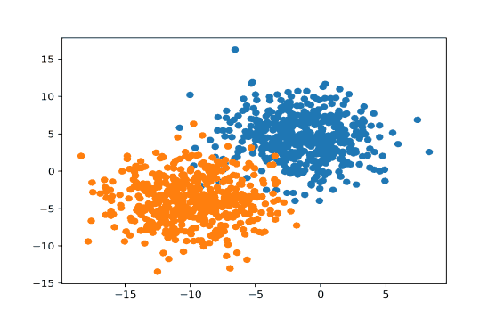

Fig 1

* **True Condition**
* **False Condition**

**ALGORITHMS:**

These are the top 10 most common binary classification algorithms:

* Naive Bayes
* Logistic Regression
* K-Nearest Neighbours
* Support Vector Machine
* Decision Tree
* Bagging Decision Tree (Ensemble Learning I)
* Boosted Decision Tree (Ensemble Learning II)
* Random Forest (Ensemble Learning III)
* Voting Classification (Ensemble Learning IV)
* Neural Network (Deep Learning)

**Basic steps for finding the solutions of ML problem:**

In this blog post, we’ll be going through the steps on setting up the pathway for finding our required results.

1. PREREQUISITES:

This is the first step in which we have some data set on which problem has been a raised this data can be in form of excel sheet or data base.

1. GET DATA:

Now from the data set we will fetch data which will undergo the process of training and testing to produce further results.

1. CLEAN DATA:

Presently the part comes that normally is the most tedious one: cleaning the information. It frequently requires up 80% of the investment of the information researchers: sorting out what of your information is really pertinent. For focussing on just structure the ML model, cleaning the information here is kept extremely paltry: we essentially drop a few additional sections inside the ML studio, which is the utilization of the Venture Segments module

1. BUILD THE MODEL:

Once the data has been cleaned (although in this case admittedly a very trivial step), the model can be built based on the given data. Thinking a few steps ahead, how can we tell if a model is well performing or not? Hence, we split the data in 80-20: we use 80% to train a machine learning model but reserve the remaining 20% for testing the model.

1. EVALUATE THE MODEL:

Now after building our model we will evaluate it by giving the model reserved 20% data for testing to see the accuracy and precision and by comparing the results of training data and tested data.

Fig 2

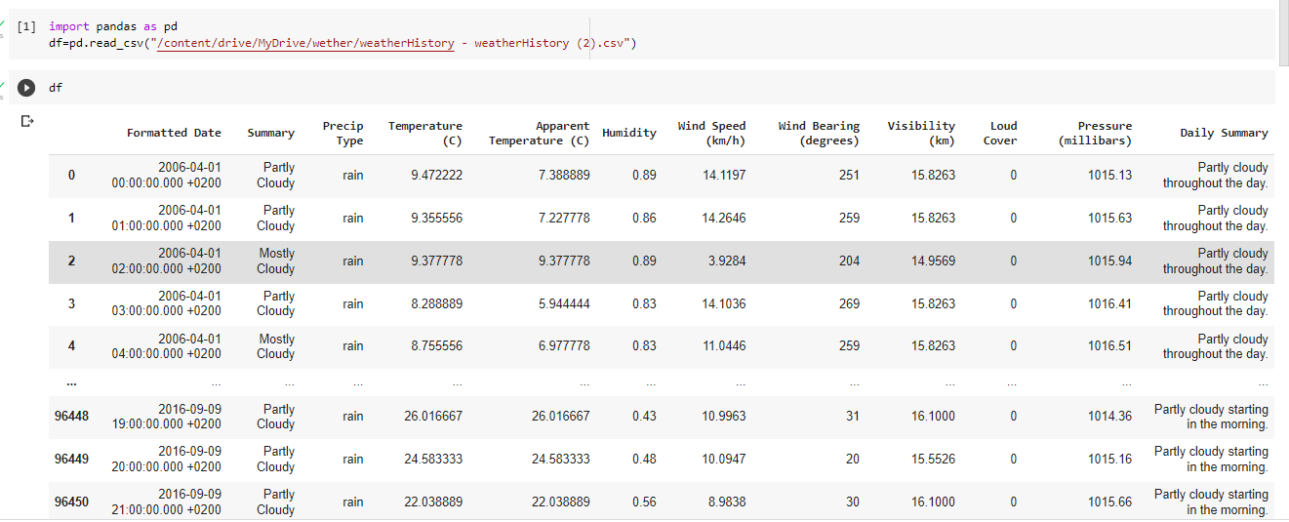Code:

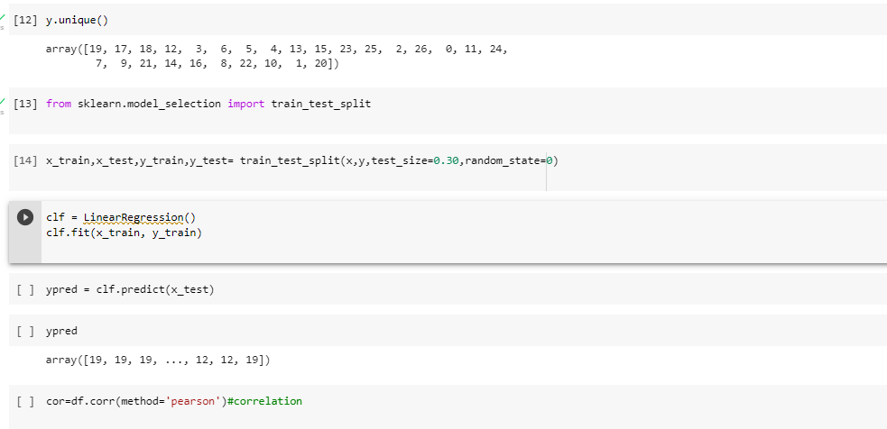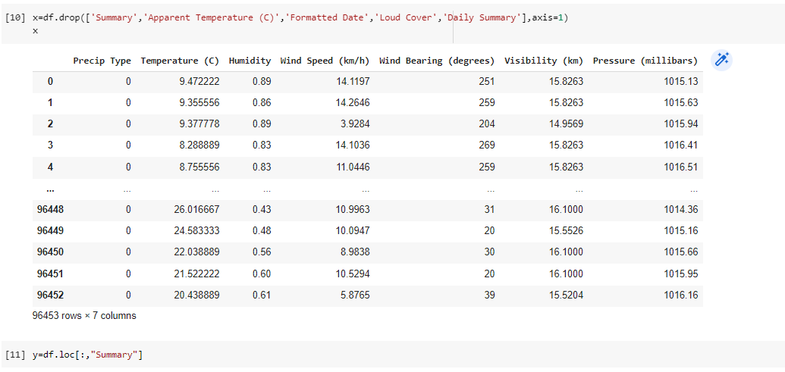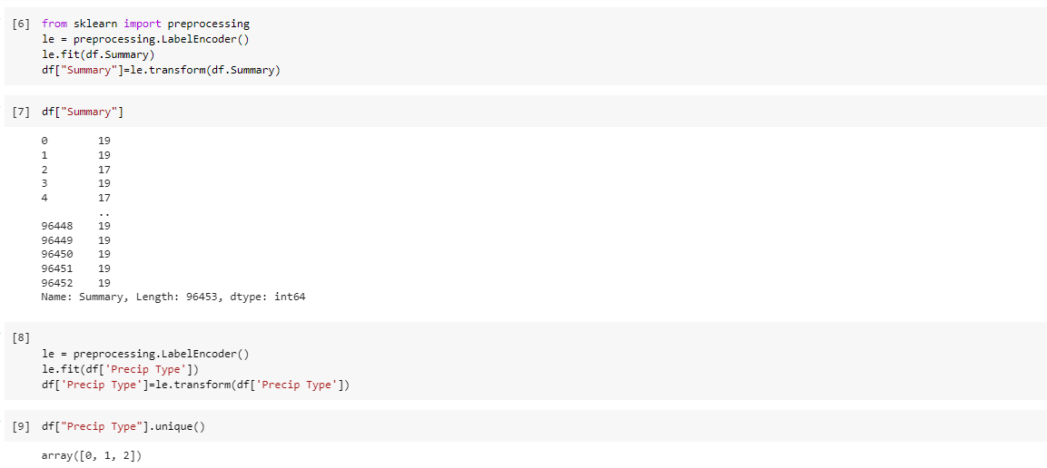

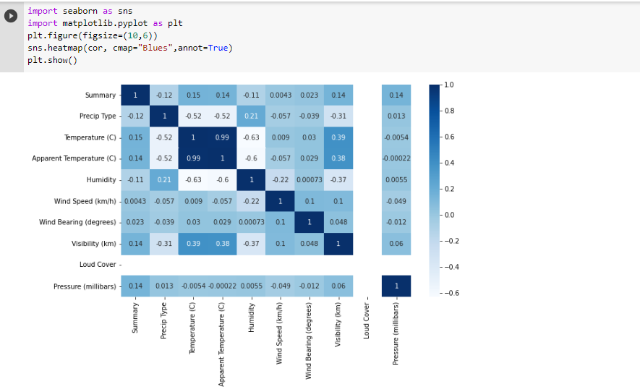

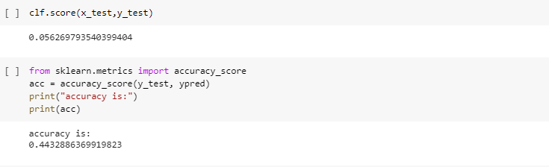

**EVALUATION OF BINANRY CLASSIFIERS:**

In this we will take an example of patient to predict that weather he has this disease or not.This will done by confusion matrix.If the model successfully predicts the patients as positive, this case is called True Positive (TP). If the model successfully predicts patients as negative, this is called True Negative (TN). The binary classifier may misdiagnose some patients as well. If a diseased patient is classified as healthy by a negative test result, this error is called False Negative (FN). Similarly, If a healthy patient is classified as diseased by a positive test result, this error is called False Positive(FP).We can evaluate a binary classifier based on the following parameters:

* True Positive (TP): The patient is diseased and the model predicts "diseased"
* False Positive (FP): The patient is healthy but the model predicts "diseased"
* True Negative (TN): The patient is healthy and the model predicts "healthy"
* False Negative (FN): The patient is diseased and the model predicts "healthy"

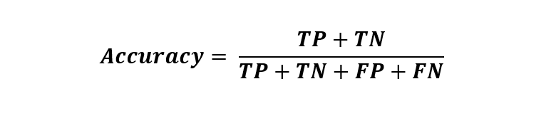After obtaining these values, we can compute the accuracy score of the binary classifier as follows:

The following is a confusion matrix, which represents the above parameters:

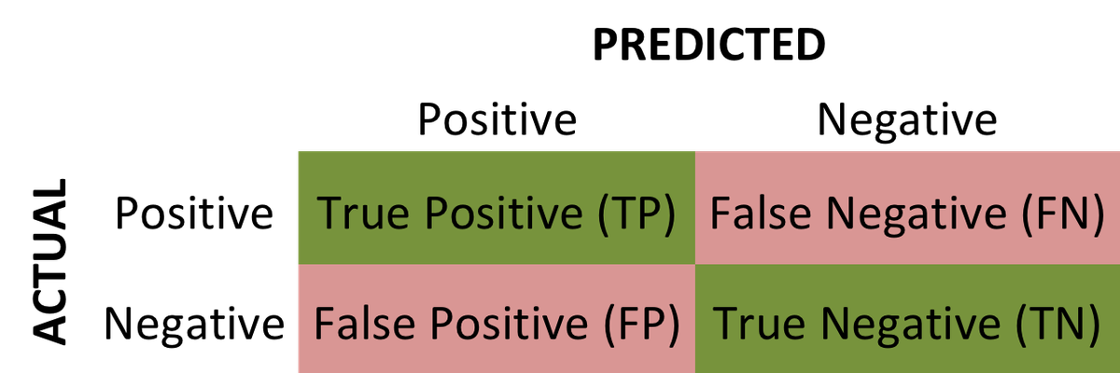

**PIPELINE BUILDING:**

Pipelines are a must in properly building a Machine Learning model. They help you organize all the steps it takes to transform data and use your model repeatedly. You can do these steps individually, but when applying your model to new data ,it won't be easy if you do not do it this way. It gives you the virtual block diagram sketch in your mind to be followed in problem solving.

